LAB4 – DS LAB
HRITIK AJAY BANSAL
CSE A, 15
180905105

PRACTICE QUESTIONS:
Q1) output:

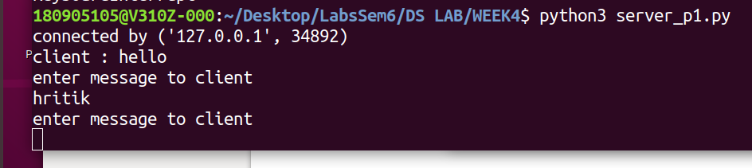
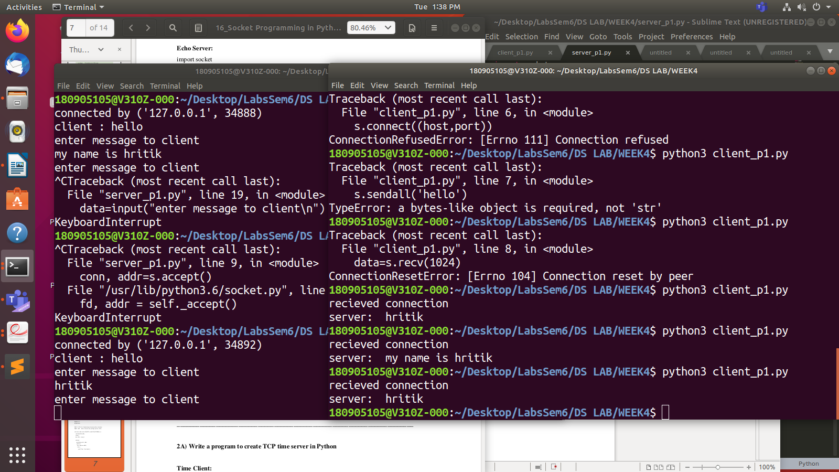

Q2)output:
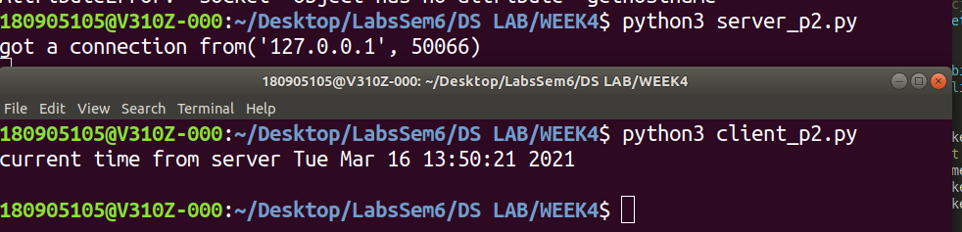

Q3)output:
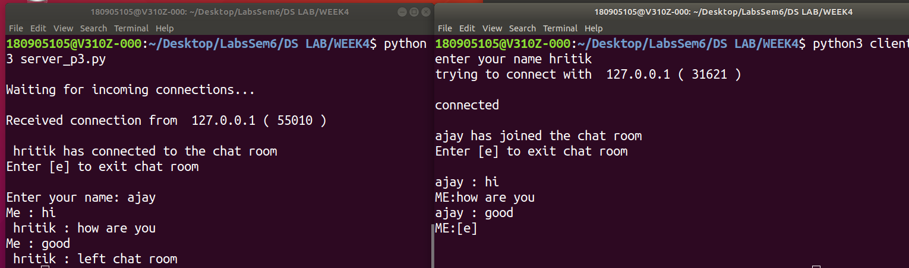

Q4)output:

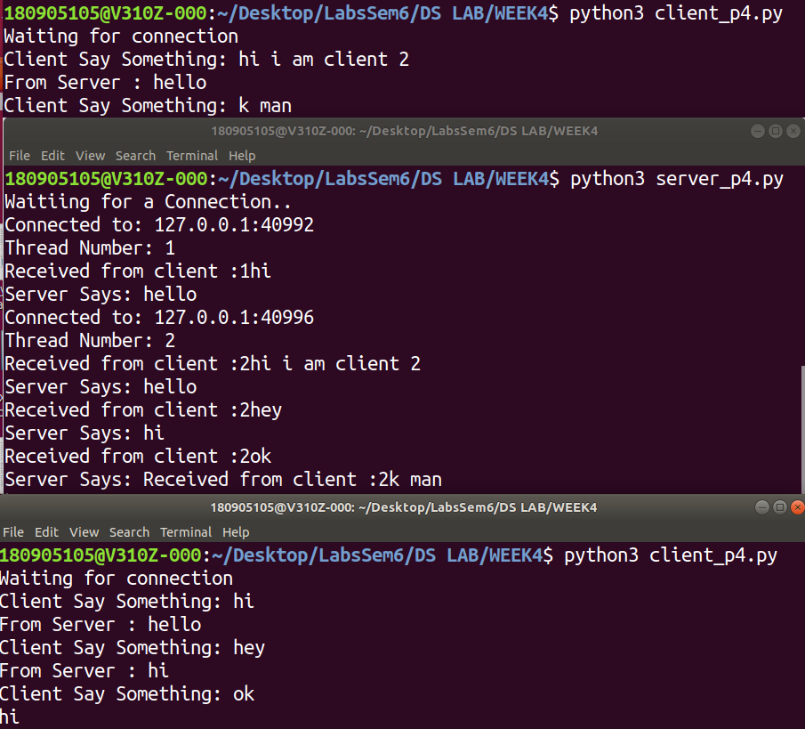

LAB EXERCISES:

Q1)
#client
import socket
sock = socket.socket(socket.AF_INET,socket.SOCK_DGRAM)
udp_host = socket.gethostname()
udp_port = 12345
msg="Hello, what time is it? "
sock.sendto(msg.encode('UTF-8'),(udp_host,udp_port))
tm,addr=sock.recvfrom(1024)
print("Time recieved from server is %s "%str(tm.decode()))
sock.close()

#server
import socket
import time
sock = socket.socket(socket.AF_INET,socket.SOCK_DGRAM)
udp_host = socket.gethostname()
udp_port = 12345
sock.bind((udp_host,udp_port))
while True:
print("Waiting ")
data,addr = sock.recvfrom(1024)
print( "Received Messages:",data.decode()," from",addr)
print("sending time to client")
currentTime= time.ctime(time.time())+"\r\n"
sock.sendto(currentTime.encode('ascii'),addr)
if not data:
break
sock.close()

output:
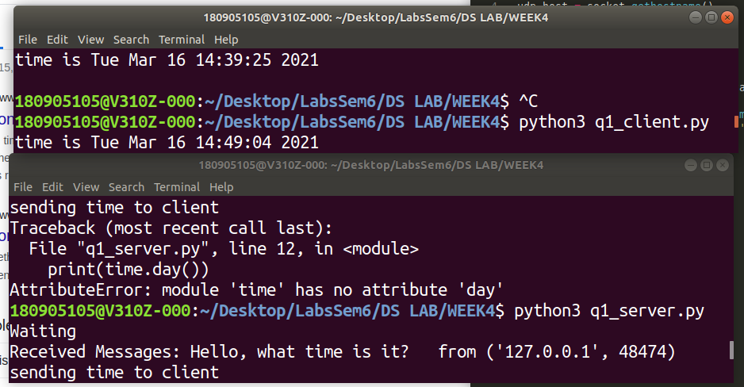

Q2)
#client:
import socket
sock = socket.socket(socket.AF_INET,socket.SOCK_DGRAM)
udp_host = socket.gethostname()
udp_port = 12345
msg=input("Enter the message here: ")
sock.sendto(msg.encode('UTF-8'),(udp_host,udp_port))
while True:
data,addr = sock.recvfrom(1024)
print( "Received Message:",data.decode())
msg=input('Enter your message here: ')
sock.sendto(msg.encode('UTF-8'),addr)
if data.decode()=='exit':
break
sock.close()

#server:
import socket
import time
sock = socket.socket(socket.AF_INET,socket.SOCK_DGRAM)
udp_host = socket.gethostname()
udp_port = 12345
sock.bind((udp_host,udp_port))
print("Waiting ")
while True:
data,addr = sock.recvfrom(1024)
print( "Received Message:",data.decode())
msg=input('Enter your message here: ')
sock.sendto(msg.encode('UTF-8'),addr)
if data.decode()=='exit':
break
sock.close()

output:
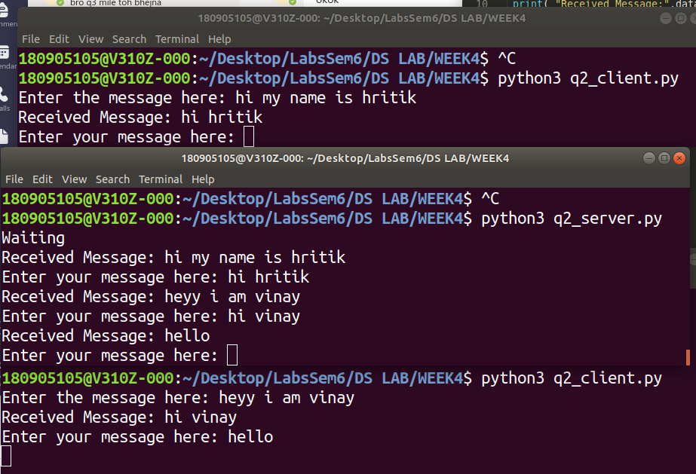

Q3)
output:

